PROJECT TITLE: Toyota Stock Data Analysis
ROLL NUMBER:-DW244

🔹 1. Problem Statement (Markdown)
Problem Statement
I am analyzing Toyota stock price data to understand how stock prices change over time and identify patterns that may help investors make better decisions.
The dataset is collected using Yahoo Finance and contains historical stock data of Toyota Motor Corporation. It includes columns such as Date, Open, High, Low, Close, Adj Close, and Volume.
The dataset contains more than 1000 rows and 6+ columns representing daily stock activity.

🔹 Import Libraries
import pandas as pd
import numpy as np
import matplotlib.pyplot as plt
import seaborn as sns

from sklearn.model_selection import train_test_split
from sklearn.linear_model import LinearRegression
from sklearn.metrics import mean_absolute_error, r2_score

sns.set()

🔹 Load Dataset (Toyota Stock Data)

import yfinance as yf

# Download Toyota stock data (ticker: TM)
df = yf.download('TM', start='2010-01-01', end='2024-12-31')

df.reset_index(inplace=True)

df.head()

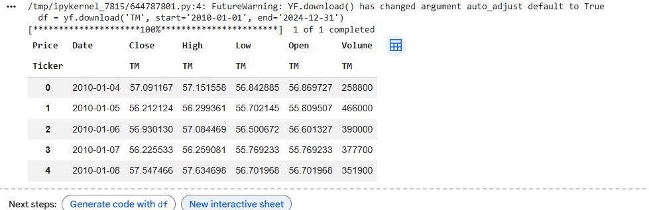

🔹 Basic Info
# Shape
print("Shape:", df.shape)

# Data types
print("\nData Types:\n", df.dtypes)

# First 5 rows
df.head()
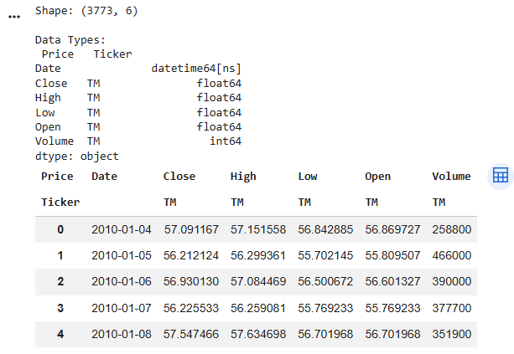

🔹 Data Cleaning
# Check missing values
print(df.isnull().sum())

# Fill missing values (if any)
df.fillna(method='ffill', inplace=True)

# Remove duplicates
df.drop_duplicates(inplace=True)

print("After cleaning:", df.shape)
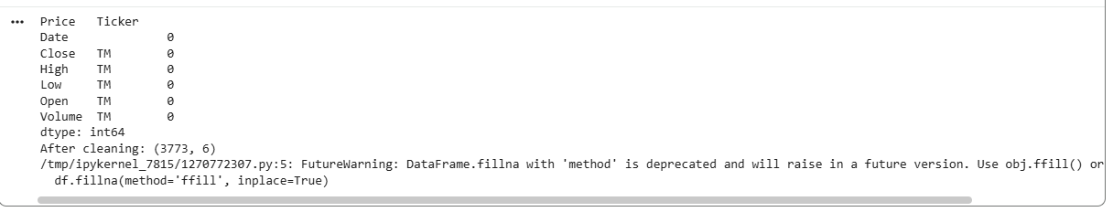
🔹 Markdown Explanation
Data Cleaning Summary
The dataset had very few or no missing values. Any missing values were handled using forward fill to maintain continuity in stock prices. Duplicate rows were checked and removed to ensure data accuracy.
🔹 Statistical Calculations
# Using Close and Volume columns

# Mean
print("Mean:\n", df[['Close', 'Volume']].mean())

# Median
print("\nMedian:\n", df[['Close', 'Volume']].median())

# Mode
print("\nMode:\n", df[['Close', 'Volume']].mode().iloc[0])

# Standard Deviation
print("\nStd Dev:\n", df[['Close', 'Volume']].std())

# Variance
print("\nVariance:\n", df[['Close', 'Volume']].var())

# Range
print("\nRange:\n", df[['Close', 'Volume']].max() - df[['Close', 'Volume']].min())

# Mid-range
print("\nMid Range:\n", (df[['Close', 'Volume']].max() + df[['Close', 'Volume']].min()) / 2)
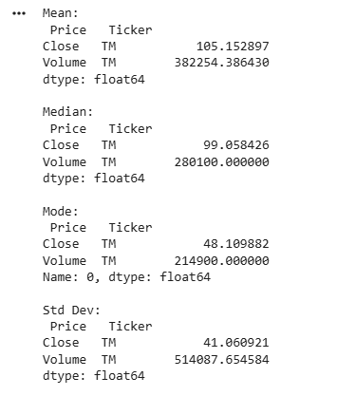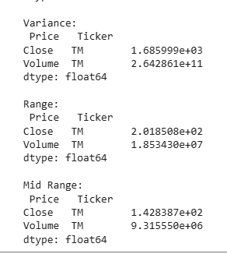
🔹 Visualizations
📊 Histogram
plt.figure()
plt.hist(df['Close'])
plt.title("Histogram of Closing Price")
plt.xlabel("Closing Price")
plt.ylabel("Frequency")
plt.show()
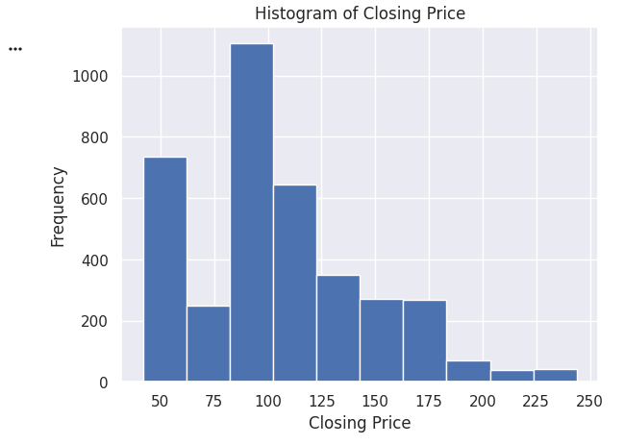
📊 Bar Chart (Year-wise Average Close)
df['Year'] = df['Date'].dt.year

yearly_avg = df.groupby('Year')['Close'].mean()

plt.figure()
yearly_avg.plot(kind='bar')
plt.title("Year-wise Average Closing Price")
plt.xlabel("Year")
plt.ylabel("Average Close Price")
plt.show()
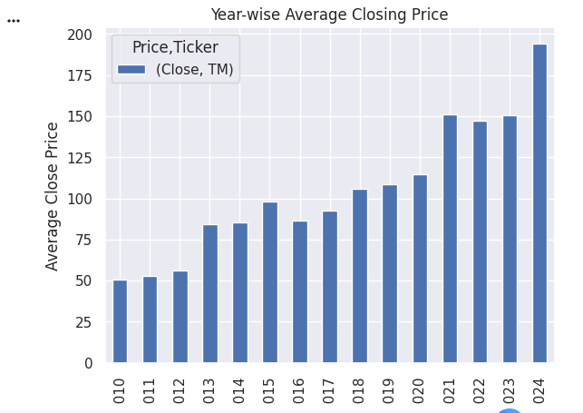
📊 Correlation Heatmap
plt.figure()
sns.heatmap(df.corr(numeric_only=True), annot=True)
plt.title("Correlation Heatmap")
plt.show()
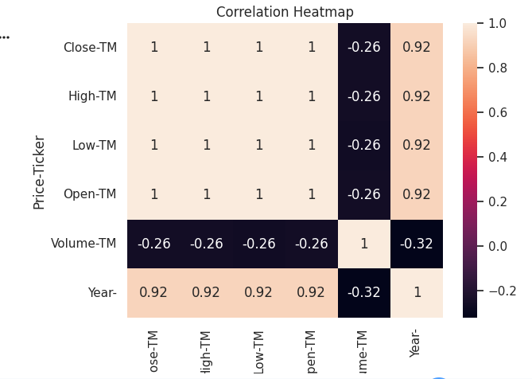
🔹 Simple Prediction Model
# Features and Target
X = df[['Open', 'High', 'Low', 'Volume']]
y = df['Close']

# Train-test split
X_train, X_test, y_train, y_test = train_test_split(X, y, test_size=0.2)

# Model
model = LinearRegression()
model.fit(X_train, y_train)

# Prediction
y_pred = model.predict(X_test)

# Evaluation
print("MAE:", mean_absolute_error(y_test, y_pred))
print("R2 Score:", r2_score(y_test, y_pred))
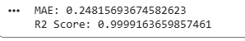
🔹 Insights & Findings
Insights
- The histogram shows that most closing prices are concentrated in a specific range, indicating stable stock behavior.
- The yearly bar chart shows a gradual increase in stock price over time, suggesting long-term growth.
- The boxplot reveals some outliers, indicating occasional sudden spikes or drops in stock prices.
Recommendations
- Investors should consider long-term investment in Toyota as the trend shows steady growth.
- Sudden spikes seen in the boxplot suggest monitoring market news before making short-term trading decisions.

Git-Hub link:-

